

ENTOMOTHERAPEUTICPOTENTIAL OFVOSR!••ulgaris MUD NEST AND VENOM AGAINST MULTIDRUG-RESISTANT BACTERIA IMPLICATED IN UPPER RESPIRATORY TRACT
INFECTIONS

BY

AKINSOWON,TEMILADEKINGSLEY(PG19/0063)
B.Tech(OAUSTECH)

ADissertation submitted totheDepartment of Microbiology, College of Biosciences,Federal UniversityofAgriculture,Abeokuta inPatialfu1i"i1ment of theRequirements of theaward ofdegree in Masters of Science in Microbiology

SEPTEMBER,2025

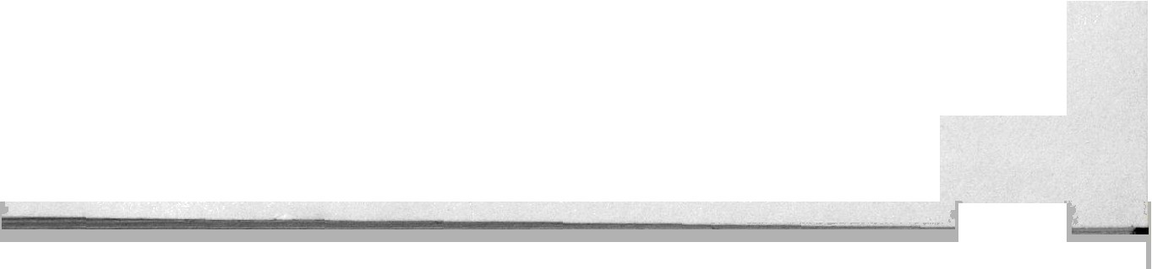

ABSTRACT
Theincreaseinmultidrug-resistant(MDR)bacteriaposesasignificantchallengeintreatingupper respiratorytractinfections(URTIs).ThisstudyinvestigatedthepotentialofVespulavulgarismud nest extract and venom as alternative treatment against multidrug-resistant bacterial strains associatedwithupperrespiratorytractinfections.Onehundredsputumsampleswerecollectedfrom patientsattheFederalMedicalCenter,Idi-Aba,Abeokuta,OgunState.Isolationofbacteriawas performed using nutrient agar, blood agar, and MacConkey agar. Bacteria were isolated using standardmicrobiologicalmethodsandwereidentifiedusingphysiological,morphological andIn-silico molecular docking. Kirby Bauer's disc diffusion testwas used todetermine the antibiotic sensitivityprofileswhileagarwelldiffusionwasusedtodeterminethesusceptibilityoftheisolates to the mud nest extract and venom. Minimum Inhibitory Concentration (MIC) and Minimum BactericidalConcentration (MBC) weredetermined.Theeffectofthecombinationofthemudnest extractandvenomwithcommercialantibioticswasevaluatedusingoverlayinoculumsusceptibility technique.Physicochemicalanalysisofthemudnestextract gottenthroughethanolic extraction whilethevenomwasgottenfromP'espulavulgarisabdomenwiththeuseofneedleandsyringeand was aseptically dispensed inanEppendorf tube. The chemical compounds in the mud nest and venomweredeterminedusingGasChromatographyandMassSpectrometry(GC-MS)andwere evaluated for their pharmacokinetic properties using in silico methods. One-way Analysis of Variance (ANOVA) was used in analyzing the data. Klebsiella pneumoniae, Escherichia coli,Pseudomonasaeruginosa,Staphylococcusaureus,Bacillussubtilis,StreptocoCcttspneumoniae, Klebsiellaoxytoca,andProteusmirabiliswereidentifiedthroughtheBergy'sManualofSystematic Bacteriology.Antibioticsusceptibilitytestingresultsrevealedmultidrugresistancewhileagarwell diffusionshowedazoneofinhibitionrangeof18.2z0.00mm—25.5z0.00mm.MICof3.125mg/ml
- 25mg/mland6.25mg/ml—50mg/mlwereobserved formudnestandvenom,respectively. MBC ofmudnest was between12.5mg/ml —50mg/ml while venom showedMBC of12.5mg/ml—100 mg/ml. Gas chromatography and mass spectrometryanalysisindicatedthe presenceofDecane,2,6,7
- trimethyl, undecane, decane among others for Vespula vulgaris mud nest and 3,6-bis(N-dimethylamino)-9-ethylcarbazole,Arsenous(trimethylsilyl)ester, Trifluorpaceticacidandcarbonic acidforthevenom. In-silicomolecular docking showed dibutyl phthalate andhexadecenoicacidas potentialleadmoleculeinthedevelopmentofnewdrugtocombatbacteriaimplicatedinURTIs. Thisstudycontributestothegrowing bodyofknowledgeonalternative therapiesandhighlights the
V

needforongoingresearchtoaddressthechallengesposedbyantibioticresistanceinclinicalsettings. The investigation from this study showed Vespula vulgaris mud nest and venom possess significant antibacterialpotencyagainstmultidrug-resistantbacteriacommonlyfoundinupperrespiratorytract infections. The results in this study support the potential of these natural substances as a viable alternative therapyfortreatinginfections caused bythesechallenging pathogens.

Vi

