ASSESSMENT OF ANTIMICROBIALACTIVITIES OF IWGELLA SATINA SEED EXTRACTS AGAINST CARBAPENEM-RESISTANT CLINICAL BACTERIAL ISOLATES

BY

ADIO,IYABODE TOYIN (PGI9/0128)

SUBMITTEDTO

THE DEPARTMENT OF MICROBIOLOGY COLLEGE OF BIOSCIENCES
FEDERALUNIVERSITYOFAGRICULTURE,ABEOKUTA,OGUNSTATE.

INPARTIALFULFILMENTFORTHEAWARDOFMASTEROFSCIENCEIN MICROBIOLOGY.

SEPTEMBER,2025.

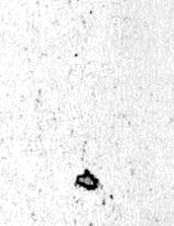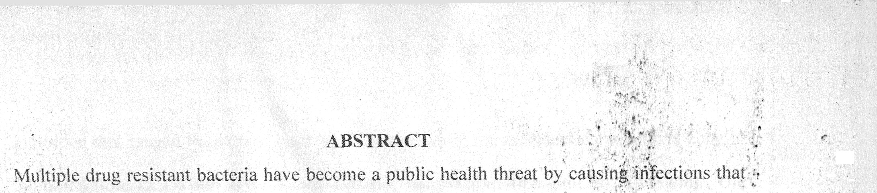
areresistancetothe antibioticsthatarecommonly‘usedfortheirtreatment.Ther"efore,thereis

theneedto developasafeandeffectivealternativeto combattheinfections causedbythese multipledrugresistantbacteria.Thisstudyaimedatassessingtheantimicrobialactivitiesof.
tbreedifferentextractsof\'pe/lasofiv‹iseedagainstcarbapenem-resistantclinicalbacieria'l"'
isolates.Thirty-three(33)bacterialisolatesfromdifferentclinicalsamples(blood,sputum,’
‘:
woundscab.earscab,urine,stool,centrallineswab)usedinthisst(id\’’iveteobtainedtroiii .
. ...
MicrobiologIdiaSnosticlaboratoriofBabcockUnivers-ityTeachingho.s.pital*lli:san-remo*
confirmation.Thirteen(13)selectedcarbapenein-resistantbacterialisolateswheresub;iectedto’
. J:
pc›lymerasechainreaction(PCR)foramplificationofgenesencoding’forcarbapcnemase.”'

threedifferentsolventswhichweien-hexanc,iiiethanolandsteriledistilledPatelusing Jacceleratedsolvent extractionmethod. "I'lie c-ritde extracts ofthe .X\.sariveeds were subjecte‹i.
tc›qualitativephytochemicalscreeningusingstandardmethods.Gas-ChromatographyPass-Spectrophotometry(GC-MS)analysiswasalsOcaiTiedouttoidentimajorphytochemicals andfattyacidsintheextracts.Theantibioticsusceptibilitytestsandminimum*’inhibitory’
concentration(UC) etcdeterminedusingagarwelldiffusionandserialdilution"m‹ithods:
“
respectively.Datawereanalyzedusinyone-ayanalysisofvariancewith P<0.05considered statisticallysignificant.Thepotencyofthe.â*..safiv‹iextracts»asassessedusingmolecular docking.Fromthethirty-three(33)testedisolatesobtained.54.5%(n=l8)wereresistanttoone or worecarbapeneliiantibiotics; 39.4% (n=13), 36.4% (n—12) and 45.5% (n=l5) were resistant toiirtipencm,meropcficiTiandertapencm,rcspcctitelf’.F'rcmthePCkresult.5.1.s%ofthe isolates carried one or two of the carbapenemasegenes. T“he aqueous extract Sf.â. .sativa seed showednotoneofinhibitionagainstthetestedisolates.Then-hexaneextracthadzoneof

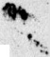
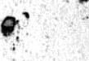

inhibitionthatrangedfrom26+3mmto6+4mmwhilethemethanolicextracthadzoneof inhibitionfrom124mmto6-£3mm.TheMICrangedfrom40mg/mLto120mg/mL.The qualitativepliytochemicalscreeningindicatedthepresenceofcardiacglycosides,steroids, phenols in all three extracts. Other phytocheinicalspresent included alkaloids, saponins, terpenoidsandflavonoids(methanolextract).tannins,alkaloidsandterpernoids(n-hexane extract) and flavonoids (aqueous extract). The GC-MS analysis revealed the presence of differentfattyacidswhichinclude9,12-Octadecadienoicacid.Octadecanoicacid.i-lexadccaooic °.cid. Cyclopropane,l,l-dichloro-2,2.3.3-tctramethyl, Methyl s:cara:e. PropyleneglycolMonoleateand11,13-Eicosadienoicacid.TheGC-MSresultswhendocked withthepenicillinbindingproteinofthebacteriarevealedPropyleneglycolSlonoleaietoliaxe thehighest bindingnegativeenergy.Thisstudy suggeststhat1S’igellasativaseedextracts (methanoland n-hexane) possess antimicrobialactivities against carbapenemresistantbacteria.

